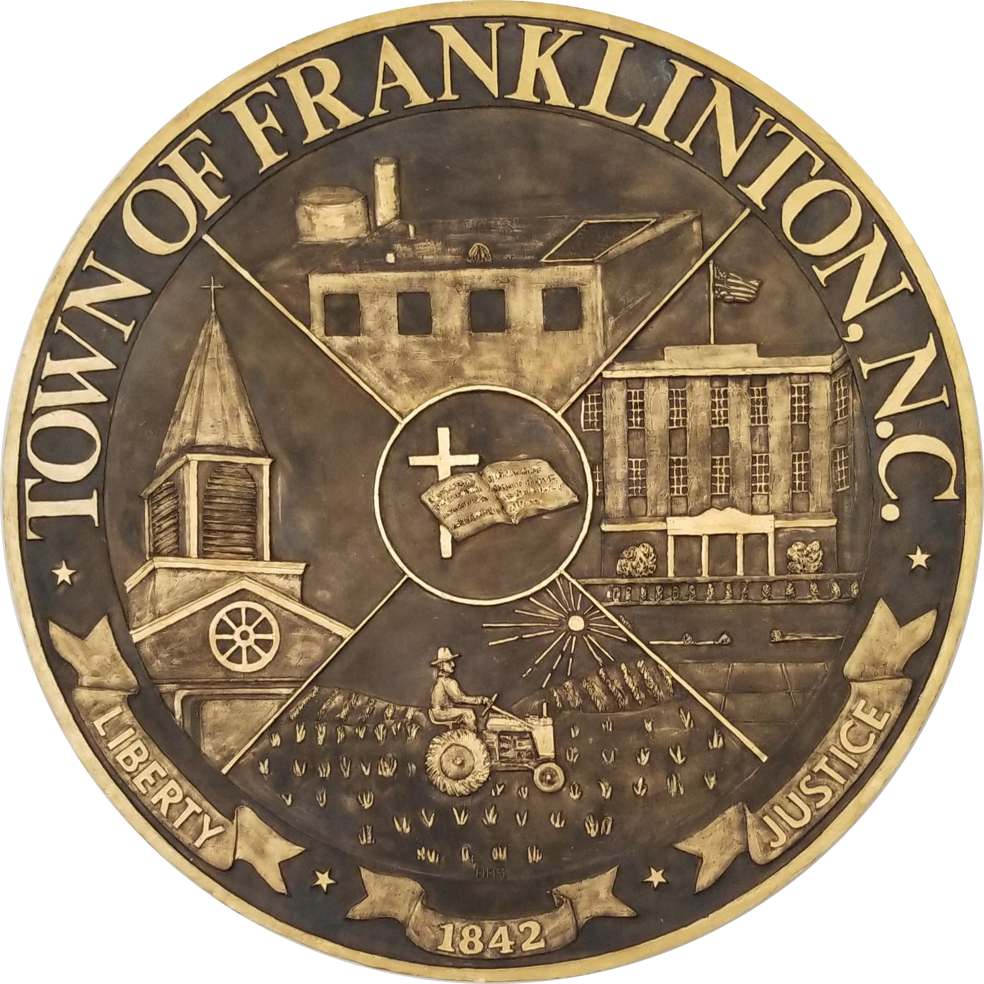

TOWN OF FRANKLINTON FOOD TRUCK PERMIT APPLICATION

APPLICANT INFORMATION

Name: Phone:
Mailing Address:

Email Address:

Property Address (Where food truck is to be stationed for event or duration of permitted time):

PROPERTY OWNER ADDRESS (If different from Applicant):

Name: Phone:
Mailing Address:

FOOD TRUCK INFORMATION

Business Name: Business Phone:
Business Mailing Address:

Contact Person(if different than above):
Vehicle Make: Model:
Vehicle Color: License Plate#:
Descriptions of items to be sold or services to be rendered:

Have you provided a copy of your current health dept permit? Yes No N/A
Have you provided a copy of your NC Sales & Use Certificate? Yes No N/A
Have you provided proof of your Liability Insurance Coverage? Yes No N/A
Have you provided a copy of your Dept of Agriculture Permit ? Yes No N/A

Event Date(s):

I certify that all of the statements made in this application and any attached documentation are true, complete, and correct to the best of my knowledge and belief and are made in good faith. I understand that false information may result in the rejection of this permit or subsequent revocation of this permit. I further certify that all conditions, restrictions, and regulations regarding the proposed use and any associated signage have been fully explained to me and I acknowledge this information and agree to abide by all requirements.

Signature of Applicant Date

Signature of Property Owner Date

Internal Use Only
Approved Disapproved

Comments

Signature of Town Official: Date:

