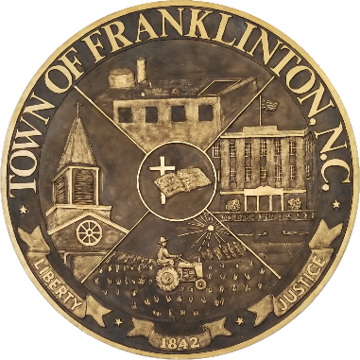
Town of Franklinton

Special Meeting - Budget
Town Hall 101 N. Main St.
May 12, 2022, 6:00 PM

AGENDA

- Call to Order Mayor Art Wright
- Minutes April 28, 2022 -Special Meeting
May 2, 2022 – Special Meeting
- Balancing of the Budget
- Upcoming Meetings
  - May 17, 2022 – Regular Board of Commissioners Meeting at 7:00 PM at Town Hall
- Adjournment

